Check Boxes:
Check boxes data tags are independent of each other. Signers may to select as many boxes as necessary.

The tags below can be copied and pasted onto a contract template if you follow these rules.

- Field Name: Every box must have a unique SFLD:Box#.

- Data Tag Font Size: Change the data tag font size to 1 when finished. Changing the tag font size to 1 prevents a large space between the button and text.

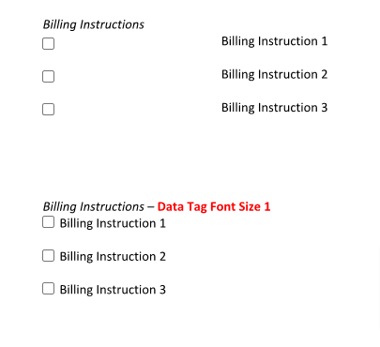

Example: Billing Instructions

[[SFLD:Box1:T=C,O=no,W=9,H=9]] Billing Instruction 1

[[SFLD:Box2:T=C,O=no,W=9,H=9]] Billing Instruction 2

[[SFLD:Box3:T=C,O=no,W=9,H=9]] Billing Instruction 3

Required Check Boxes:
To make the tag required, add a comma and R=Yes into the tag.

Example: Signer Required to Check for Policy Acknowledgement

[[SFLD:Box4:T=C,O=no,W=9,H=9,R=Yes]] I confirm that all guests listed are age 18 or older.

